Motivators: The Aesthetic Motivator
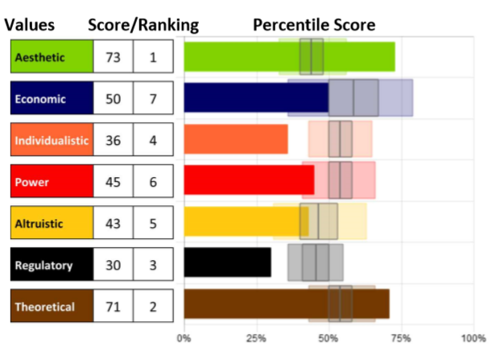
Knowing our specific level of
motivation can be crucial to
helping us understand what
drives our beliefs and actions so
we can bring them into
alignment.

Remember that although we can
explore each motivation
individually, they cannot be
separated. They can only be distinguished; however, all motivators
integrate to influence us.

The Aesthetic Motivator - the drive for balance, harmony and form

The main motivation in this driver is the strong desire and need to
achieve harmony between the world around us and ourselves (within)
while creating a sustainable work/life balance between the two. It is
the need for Self-Expression and the higher a person scores in
Aesthetic, the more alternative they are in their approach to the world;
they will be influenced by how the outside makes them feel.

Creative, imaginative, artsy, mystical, and expressive, those high
in this style may redefine and resist real world approaches to
current challenges.

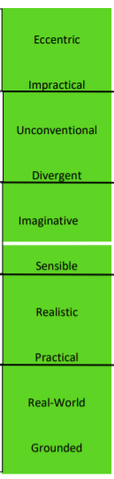
Using this descriptor scale, you can identify a key component to each person’s score in this motivation, as well as see how the scores range from Very Low to Very High, noted by the black lines between each set of descriptors. Each word represents 10 points of 100 on the scale (example: Practical people score between 20-29, Impractical people score between 80-89 in this dimension).
The white line indicates 50%, perfect balance between high and low in the motivation. Those who score closer to 50% will be situational in applying this motivator. Moving further from that line (high or low) indicates which areas are the more influential.

Whether scores are high or low, the motivators with the furthest distance above or below 50% (above or below “perfect balance” in the center) will be the highest influencers leading to the greatest impact on the decisions being made.

Strengths and Limitations

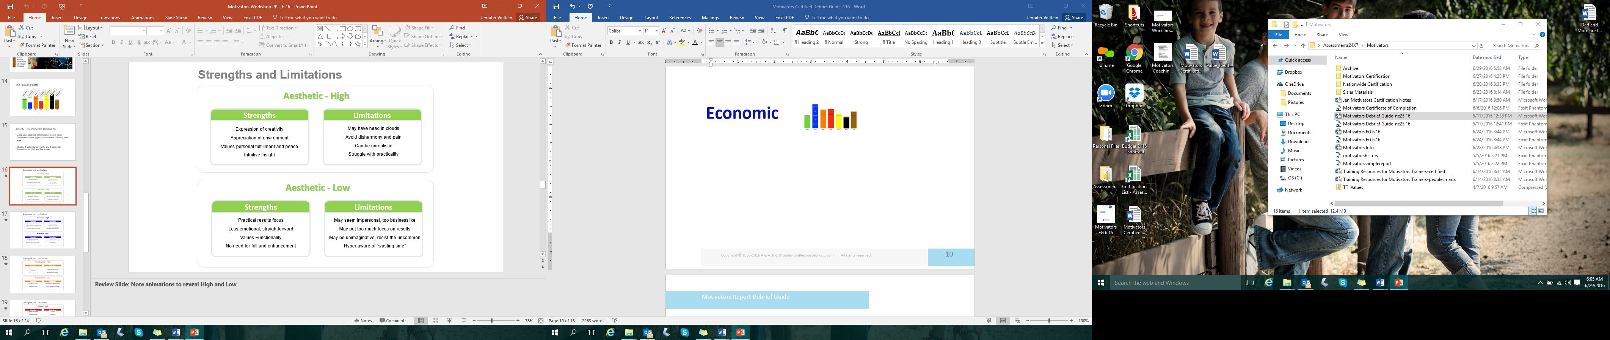

- What drives you in this motivation?
- How can that be helpful and supportive?
- How can that limit you?

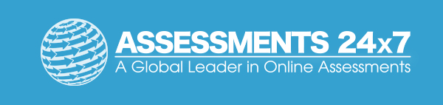Assessments 24x7 LLC 5927 Balfour Court, Ste. 103 Carlsbad, California 92008 USA (206) 400-6647

